***Audit Manager New Rack Audit Information***

**Revision: 1.0**

|  |  |  |  |
| --- | --- | --- | --- |
| Date | Revision | Author | Description |
| 2021/04/26 | 1.0 | Josh Chu | Initial creation from BNPP request |
|  |  |  |  |
|  |  |  |  |
|  |  |  |  |

**Eaton**

[www.eaton.com/powerquality](http://www.eaton.com/powerquality)

LEGAL NOTICE

Copyright © 2020. Eaton. All rights reserved. The contents of this document constitute valuable proprietary and confidential property of Eaton Corporation and are provided subject to specific obligations of confidentiality set forth in one or more binding legal agreements. Any use of this material is limited strictly to the uses specifically authorized in the applicable license agreement(s) pursuant to which such material has been furnished. Any use or disclosure of all or any part of this material not specifically authorized in writing by Eaton Corporation is strictly prohibited.

**Contact Eaton Support**

For your convenience, Eaton provides support to assist you with questions on installation, operation and troubleshooting. Please contact us at:

[softwareconnectivityts@eaton.com](mailto:softwareconnectivityts@eaton.com)

800-356-5737 option 2, option 5, option 1

# Contents

Contents 3

1. Overview 4

2. Design 5

# Overview

There is a basic rule that if a rack has been added to one incomplete manual audit, this rack should not be able to be added to another manual audit.

Incomplete manual audit means one audit is not in any one of the following status:

* Completed
* Completed With Error
* Incompleted – Error
* Canceled

With the audit information be shown in the list, the user will be able to know which rack can be added.

# Design

The change is in the Racks list when a user tries to add racks in an audit(see image attached). There will be two new columns. These columns are Audit Name and Status. If one rack has been added in another audit, the audit name and status will be shown in the list.

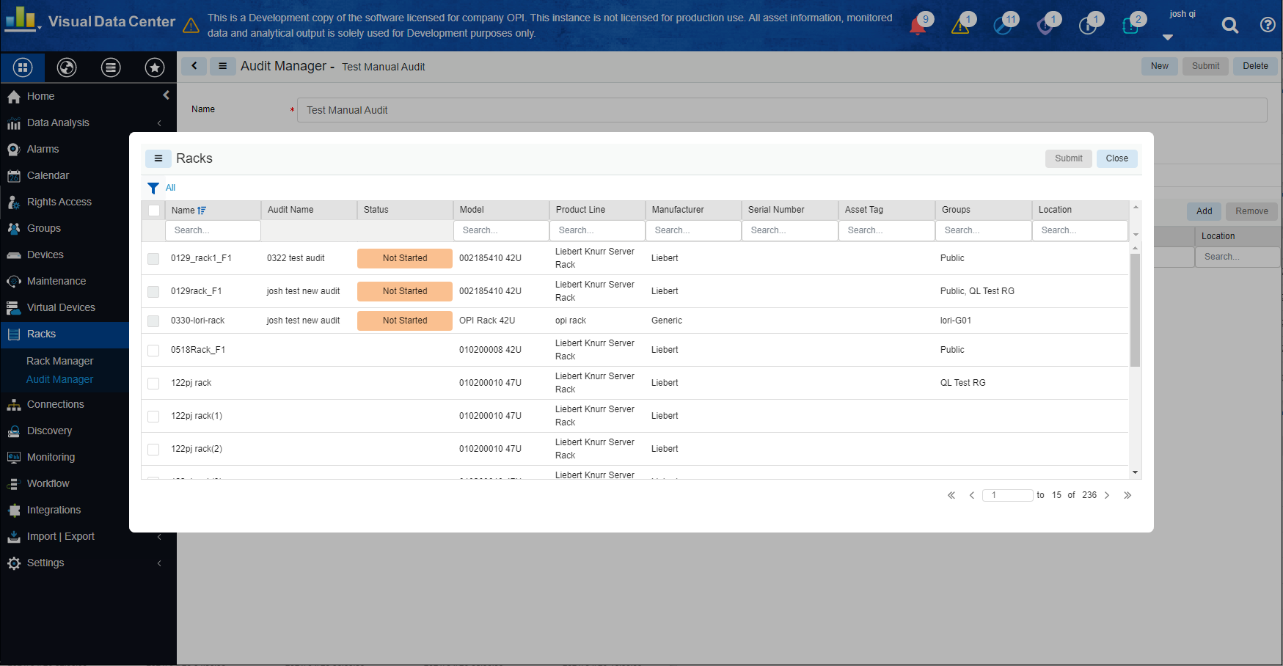  
  
The check box will be disabled (which means the racks are not able to be added in the current audit) with the following conditions.  
• The rack is already in an audit and the status of the audit is Not Started  
• The rack is already in an audit and the status of the audit is In Progress  
  
The check box will be enabled with the following conditions.  
• There is no audit  
• The rack used to be in an audit and the status of the audit is Completed  
• The rack used to be in an audit and the status of the audit is Completed With Error  
• The rack used to be in an audit and the status of the audit is Incompleted – Error

* The rack used to be in an audit and the status of the audit is Canceled